**PYTHON PROGRAM 1:**

**Python Program to Count the Occurrences of a Word in a Text File.**

t = open("shwe.txt","r")

d = dict()

for l in t:

a = l.strip()

b = a.lower()

words = b.split(" ")

for w in words:

if w in d:

d[w] = d[w]+1

else:

d[w] = 1

for i in list(d.keys()):

print(i, ":", d[i])

**shwe.txt**

Blue Yellow

Red Blue

Green Black White

White Orange Voilet

**OUTPUT:**

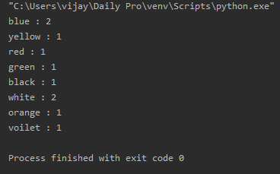

**C PROGRAM 2:**

**Write a program in C to rotate an array by N positions.**

#include <stdio.h>

void shiftArr1Pos(int *arr1, int arrSize)

{

int i, temp;

temp = arr1[0];

for(i = 0; i < arrSize-1; i++)

{

arr1[i] = arr1[i+1];

}

arr1[i] = temp;

}

void arr1Rotate(int *arr1, int arrSize, int rotFrom)

{

int i;

for(i = 0; i < rotFrom; i++)

{

shiftArr1Pos(arr1, arrSize);

}

return;

}

int main()

{

int arr1[] = {0,3,6,9,12,14,18,20,22,25,27};

int ctr = sizeof(arr1)/sizeof(arr1[0]);

int i;

printf("The given array is : ");

for(i = 0; i < ctr; i++)

{

printf("%d ", arr1[i]);

}

printf("\n");

printf("From 4th position the values of the array are : ");

for (i = 4; i < ctr; i++)

{

Printf ("%d ", arr1[i]);

}

printf("\n");

printf("Before 4th position the values of the array are : ");

for(i = 0; i < 4; i++)

{

printf("%d ", arr1[i]);

}

printf("\n");

arr1Rotate(arr1, ctr, 4);

printf("\nAfter rotating from 4th position the array is: \n");

for(i = 0; i<ctr; i++)

{

printf("%d ", arr1[i]);

}

return 0;

**OUTPUT:**

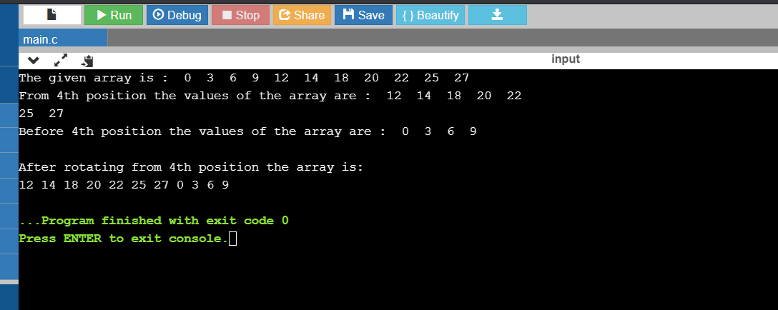

**PYTHON PROGRAM 3:**

**Write a Python Program to count the number of strings, provided string length is 2 or more and the first and last character are same from a given list of strings.**

def match_words(words):

ctr = 0

for word in words:

if len(word) > 1 and word[0] == word[-1]:

ctr += 1

return ctr

print(match_words(['hia', 'aba' , '363']))

**OUTPUT:**

